2019/2020

Sandholm identified a desireable set of properties often

associated with multi-agent negotiation protocols. Describe

these.

[ 15 Marks ]

(b)

Explain briefly why auctions often form an important mechanism

within multi-agent systems.

[ 5 Marks ]

(c)

Identify and briefly explain the dimensions under which auction

protocols can be characterised.

[ 10 Marks ]

(d)

Explain in detail the *Vickrey Auction*.

Your answer should include pseudo code to illustrate the

process.

[15 Marks ]

(e)

Comment briefly why the Vickrey Auction has received such

attention within the multi-agent systems literature.

INTRO NEGOTIATION

Def: ”The process of several agents searching for an agreement”

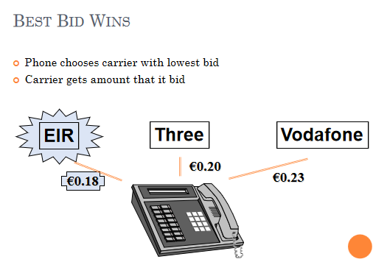

### ****Slide 3: Phone Call Competition Example****

#### ****Scenario****:

* A customer wants a long-distance call and carriers compete by submitting simultaneous bids.
* The system automatically selects the carrier with the **lowest bid** to handle the call.

#### ****Example****:

* Bids: Three (€0.20), EIR (€0.18), Vodafone (€0.23).
* **Outcome**: EIR wins with the lowest bid (€0.18) and charges this price

This showcases negotiation as a strategic and competitive process without direct communication.

In the traditional bidding system, the win-for-lowest mechanism is a direct negotiation strategy to secure the customer,

the carrier with the **lowest bid wins** and charges its **own bid price**.

**Issues**:

Carriers are incentivized to engage in **strategic behavior**, such as trying to guess competitors' bids and undercut them, which can lead to unstable pricing behavior.

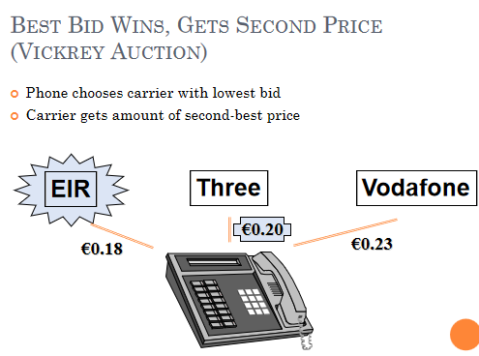

#### ****Vickrey Auction Mechanism****:

* In a Vickrey Auction, the carrier with the **lowest bid still wins**, but it charges the **second-lowest bid price** instead.
* **Example**:
  + Bids: Three (€0.20), EIR (€0.18), Vodafone (€0.23).
  + Outcome: EIR wins but charges €0.20 (the second-lowest price).
* **Key Advantage**:
  + The winner benefits without being penalized by overly aggressive pricing.
  + This creates a fairer outcome while preserving competition.

#### ****Attributes of the Vickrey Auction****:

* **Eliminates Strategic Behavior**:
* Carriers no longer need to invest resources in guessing competitors’ bids because the final price isn’t tied to their exact bid. Instead, carriers focus on submitting truthful, cost-based bids.
* **Fairness**: The winning carrier earns reasonable revenue (second-best price) while the customer still benefits from competitive rates.

The Vickrey Auction resolves the challenges of the traditional mechanism by aligning incentives, reducing strategic complexity, and ensuring both fairness and efficiency in competitive negotiations.

In Conclusion we can say that the **Best strategy is to bid the true value.** But it is still susceptible to anti-social behaviour & shilling

NEGOTIATION

### ****One to One Negotiation****

### ****Monotonic Concession Protocol****

The **Monotonic Concession Protocol** describes a structured **negotiation framework** designed for two agents to reach an agreement by progressively adjusting their proposals over multiple rounds.

* **Details**:
  + Negotiation occurs over a series of **rounds**:
    - Round 1: Agents make initial proposals.
    - Subsequent Rounds: Agents either **concede** (offer a proposal better for their opponent) or **stick** with their current proposal.
    - Ends when either **agreement** is reached or **conflict** arises.
  + The framework encourages systematic progression toward consensus.

### ****Monotonic Concession Protocol (Scenarios)****

#### Initial Proposals

* **Content**: Shows each agent (A and B) presenting their initial proposals.
* **Details**:
  + The starting point of negotiation.
  + Proposals reflect the agents’ opening positions.

#### Both Concede

* **Content**: Both agents make concessions.
* **Details**:
  + Each adjusts their proposal, moving closer to a mutually acceptable agreement.
  + Reflects cooperative negotiation dynamics.

#### One Sticks, One Concedes

* **Content**: Agent A holds their position while Agent B concedes.
* **Details**:
  + Highlights a situation where one party adapts more, showing flexibility or a lower risk tolerance for conflict.

#### Agreement or Conflict

* **Content**: Possible outcomes when neither agent concedes.
* **Details**:
  + If **both agents stick**, no progress occurs, resulting in **conflict** (the worst outcome).
  + Agreement happens when one proposal aligns with the other’s preferences.

### ****Concession and Conflict Definitions****

**Concession**:

A concession occurs when an agent modifies their proposal to **improve the outcome for their opponent** compared to the previous round, showing the will to compromise

**Agreement**:

Agreement is achieved when One agent’s proposal is better or equal to the opponent’s current proposal.

**Conflict**:

Occurs when neither party concedes during a round, signaling a negotiation deadlock.

### ****Negotiation Strategy (Zeuthen)****

to solve this monotonic concession protocol we introduce the **Zeuthen Strategy, its a strategy that decides** when an agent should concede in a negotiation based on their **risk tolerance.**

**Details**:

The agent with the **lower willingness to risk conflict** should concede.

Risk is measured as:

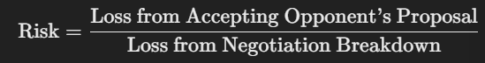

* The agent with the **smaller ratio** (lower risk) has more to lose from a failed negotiation and should make a concession.

#### ****Example****:

* Agent A values an item at €100 and offers €80.
* Agent B demands €85 for an item valued at €90.
* **Risk Ratios**:
  + Agent A: 5/20=0.25
  + Agent B: 10/5=2.0
* **Outcome**: Agent A, with lower risk (0.25), should concede and move closer to €85.

### ****Many to Many Negotiation****

### ****Multilateral Concession Protocol****

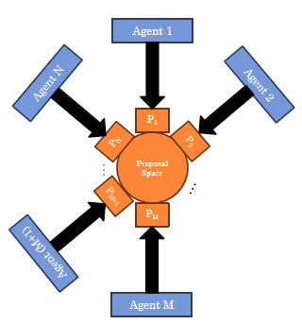

#### Overview:

* Describes negotiation among multiple agents instead of just two.
* Each agent must interact with **N other participants** or use a **centralized system** for coordination.

#### Concepts Definitions:

**Conflict**: Occurs when no agent concedes during a round.

**Agreement**: Reached when one proposal is acceptable to all agents.

**Concession-> how is it defined?**

#### Possible Concession Strategies:

* **Strong Concession**: Make a proposal that Benefits all other agents.
* **Weak Concession**: ...Benefits at least one other agent.
* **Pareto Concession**: ...Improves one agent’s outcome without worsening others.
* **Utilitarian Concession**: ...Maximizes total utility.
* **Egalitarian Concession**: ...Increases the minimum utility among agents.
* **Nash Concession**: ...Increases the product of utilities.
* **Egocentric Concession**: ...Sacrifices one’s own utility for agreement.

### ****One to Many Negotiation****

### ****Auctions****

#### General Overview

* Auctions are negotiations between an auctioneer and multiple bidders; The auctioneer offers goods or services, while bidders compete to purchase them.
* Auctioneer wants to allocate the goods to one of the bidders by maximasing the price; while bidders desire to minimise the price.

The main parameters that support an auction and what possible values exist for each parameter are:

|  |  |
| --- | --- |
| Value of goods | Private,  public/common,  Correlated |
| Winner determination | First price,  second price |
| Bids may be | Open cry,  Sealed |
| Bidding may be | One shot,  ascending,  descending |

#### English Auctions

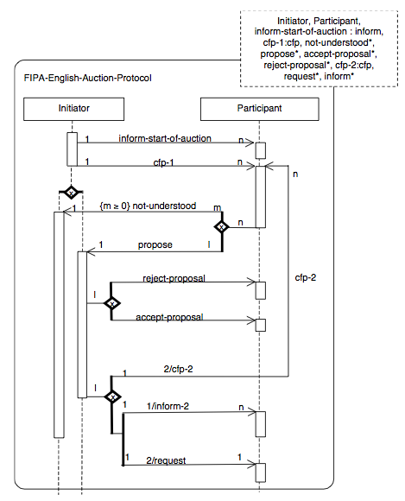

* **Process**:
  + Auctioneer starts a round specifying the current minimum prices (initially **the reserve price**) (reserve price is the minimum price that must be reached for the item to be sold.)
  + Bidders propose prices higher than the current minimum.
  + The highest bid wins unless no further bids are made -> Win determination: **first price**
* **Characteristics**:

**Open Cry**: Bidding occurs publicly, and participants can hear or see each other's bids in real time.

**Ascending**: The auctioneer starts with an initial minimum price (reserve price), and participants incrementally raise their bids.

In an English auction, the dominant strategy is to:

* **Incrementally bid slightly more than the current highest bid** until reaching your personal valuation (the maximum amount you're willing to pay).
* Once the bidding exceeds your valuation, you should **withdraw** to avoid overpaying.
* **Susceptibilities**:
  + **Winner’s Curse**: The winner overestimates the value of the goods during the competitive bidding process and ends up paying more than the item's true worth.
  + **Shills**: Fake bidders introduced into an auction to artificially inflate the bidding price.

#### Dutch Auctions

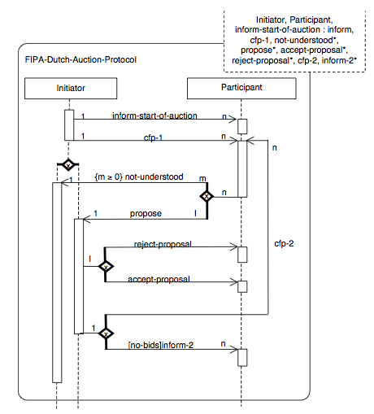

* **Process**:
  + Auctioneer starts a round specifying an artificially high bid
  + If no bidders agree with the valuation, then the auctioneer sends out a new lower price.
  + The winner is the first bidder to accept the current price for the item.
* **Characteristics**:
  + Open-cry, descending bids.
  + No dominant strategy due to uncertainty.

#### First-Price Sealed-Bid Auctions

auctioneer

Bidders

#### ****Process****:

**Bidders Submit a Single Bid**:

* 1. Each bidder submits **one bid** without knowing the amounts submitted by other participants. -> One shot auction
  2. These **bids are submitted in a "sealed envelope**" or privately, ensuring that no bidder can adjust their bid based on others.

**Winner Determination**:

* 1. After all bids are submitted, the auctioneer opens the bids and evaluates them.
  2. The **highest bid wins** the auction.

**Payment**:

* 1. The winning bidder pays the **exact amount they bid** for the item, unlike other auction types (e.g., Vickrey auctions) where payment is determined differently.

#### ****Example****:

* An antique vase is being auctioned through a first-price sealed-bid auction.
* Bidders submit the following bids:
  + Bidder A: €500.
  + Bidder B: €450.
  + Bidder C: €520.
* **Result**:
  + Bidder C wins the auction with the highest bid (€520) and pays €520.
* **Best Strategy**:
  + Bid below true valuation to maximize utility.

#### Vickrey Auctions (already done in INTRO NEGOTATION)

* **Process**:
  + Second-price and sealed-bid auction.
  + Highest bid wins, but the winner pays the second-highest bid.
* **Advantages**:
  + Encourages truthful bidding.
* **Challenges**:
  + Vulnerable to antisocial behavior, such as fake bids.

### ****Phone Call Competition Example****

* **Scenario**:
  + Carriers submit simultaneous bids for long-distance calls.
  + Lowest bid wins.
* **Comparison**:
  + Traditional Mechanism: Winner charges their bid price, encouraging strategic behavior.
  + Vickrey Auction: Winner charges the second-lowest price, reducing incentives for manipulation.

### ****Conclusion****

The presentation covers:

* **Negotiation protocols** for both two-party and multi-party scenarios.
* Strategies to manage concessions and risks.
* Applications in auction settings to promote fairness and efficiency.

If you'd like to focus on specific slides or concepts, let me know!